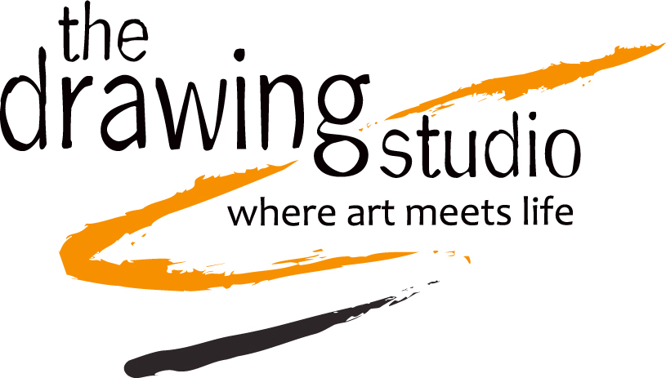

CALL TO ARTISTS - FIGURE SHOW

You are invited to participate in The Drawing Studio’s Spring 2016 Figure Show, Art Undressed: A Celebration of the Human Form.

Art Undressed: A Celebration of the Human Form
April 16 - May 7
The Drawing Studio
2760 N. Tucson Blvd.
Tucson, AZ 85716

ELIGIBILITY
Art Undressed is open to artists currently residing in Arizona, working in all media and themes related to the figure (nude, clothed, portrait) All works must be original and completed within the last two years. Artists may not withdraw accepted works before the exhibit closes May 7. Each artist may submit a maximum of one artwork — no multiple entries. All wall–hung work must be framed and/or equipped with ready–to–hang wire, cleats, or loop hanging devices.

ARTIST DATES AND TIMES

Artwork drop off: April 10-11, 12-5p
Opening reception: April 16, 6-9p
Closing: May 7
Artwork pick up: May 9, 9a-6p

Show hours: M-F, 9-4p and on weekends during Open Studio sessions.

The public is invited to the opening, which will feature food, music, and a live costume life-drawing session! Bring your easels, boards, and chairs. (Minimal art supplies will be provided for beginners, or those who want to try it.)

SALES & PUBLICITY
All sales will be split 60% artists; 40% TDS. We reserve the right to photograph all exhibited works and to use reproductions for publicity and/or educational purposes.

For more:
Tanya Rich, TDS exhibits
520-620-0947
exhibits@thedrawingstudio.org.

